

**VECTOR SPACE MODEL**

**DEVELOPER NAME: SHAYAN NOORULLAH**

**DEVELOPMENT FIELD: INFORMATION RETRIEVAL**

**PROGRAM WITH GUI IMPLEMENTATION (WORKING SS):**

**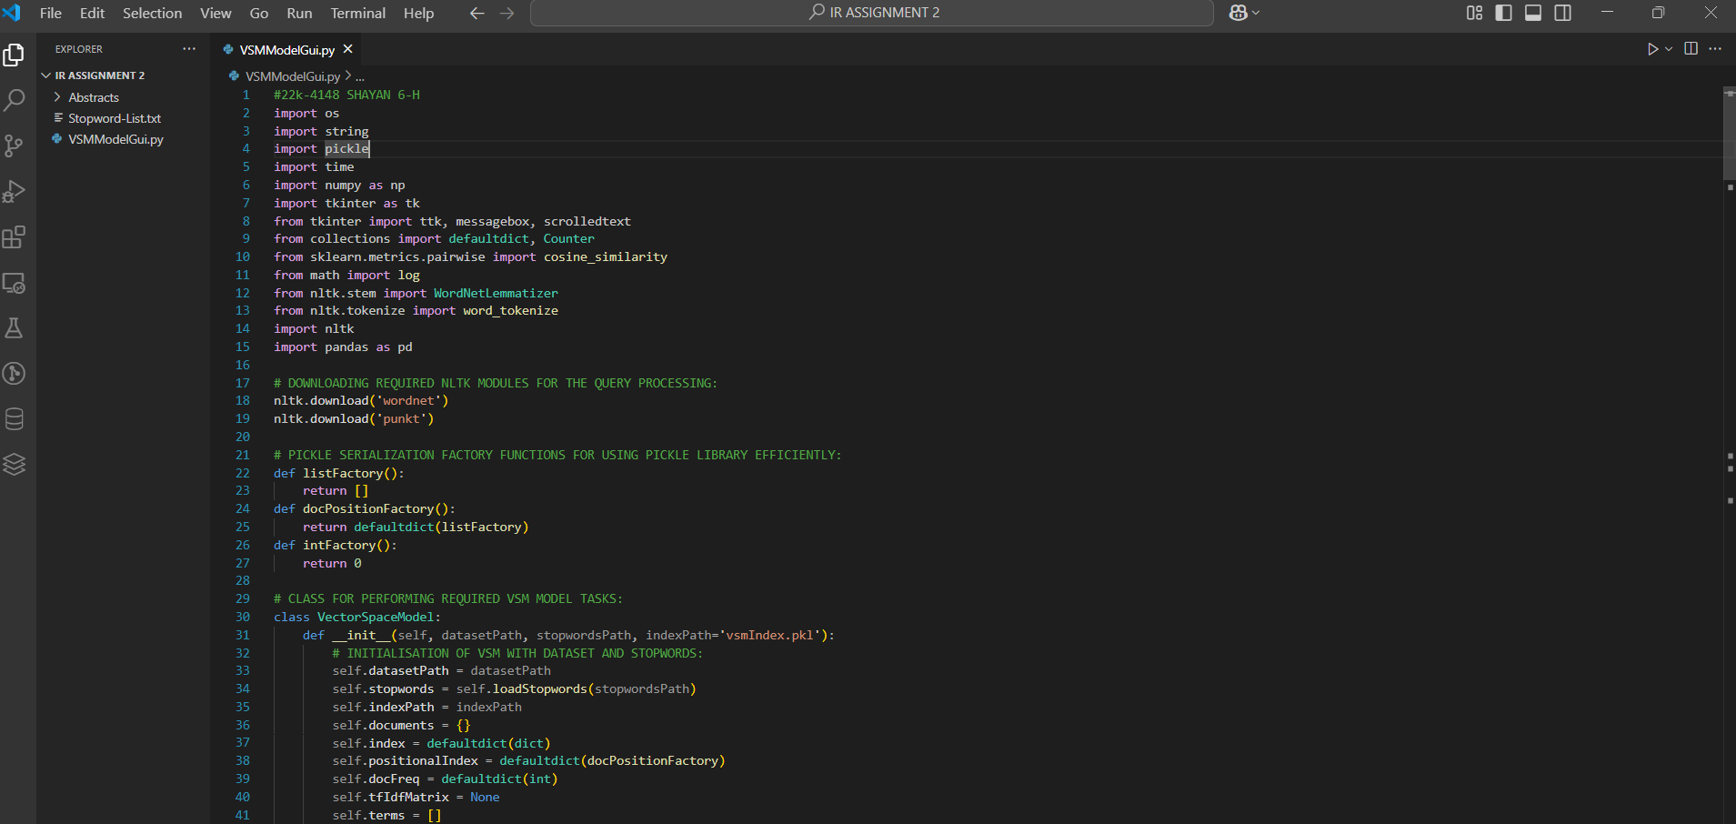  
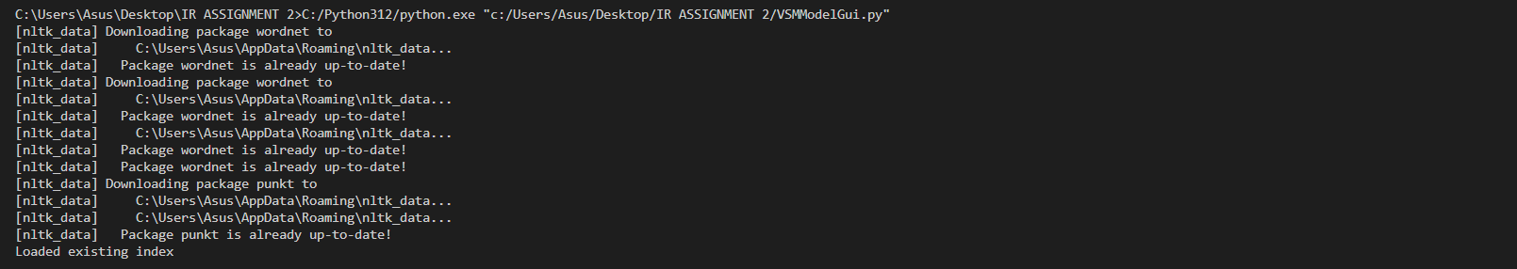**

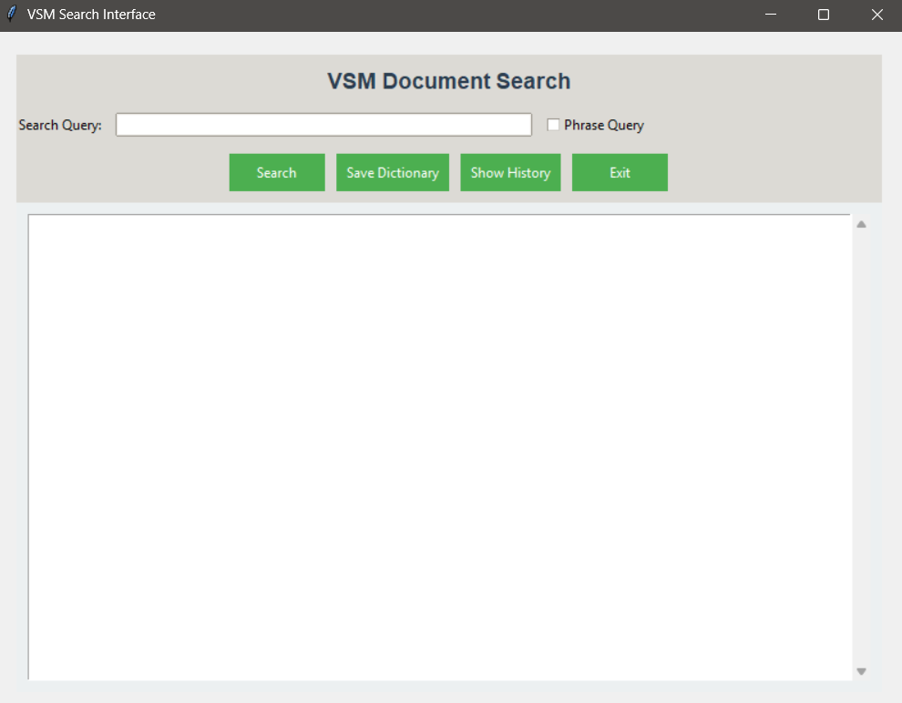

SEARCH QUERY: (Sorted according to the ranking score)

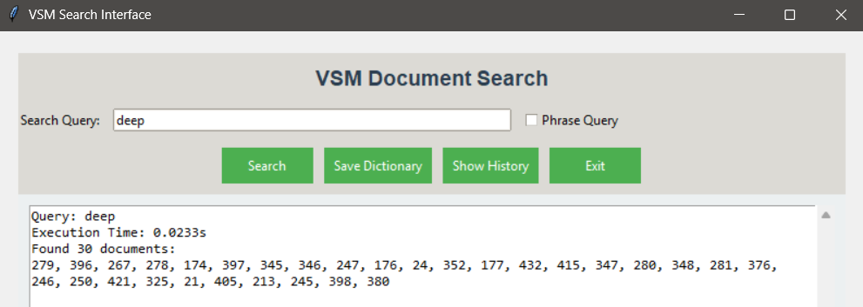

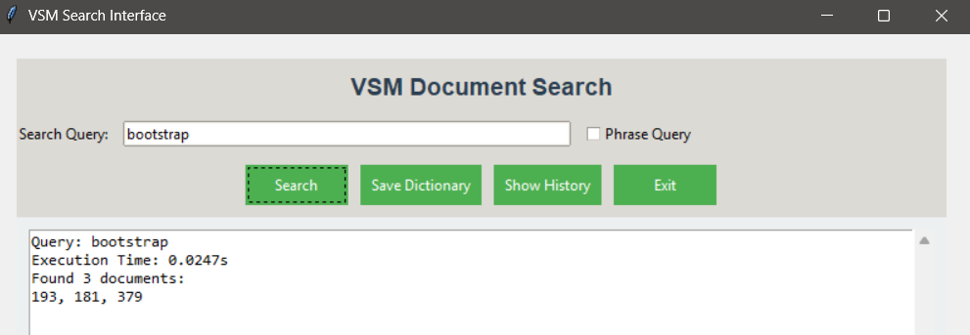

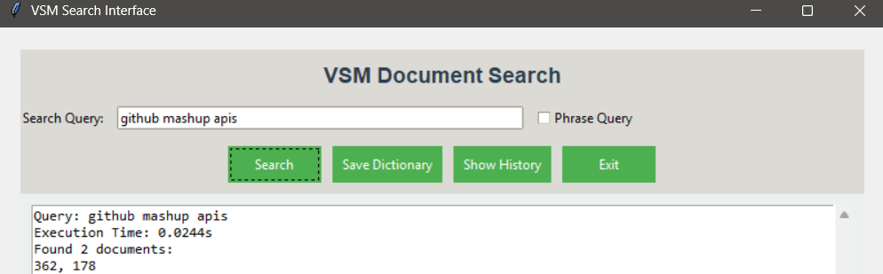

SAVE DICTIONARY:

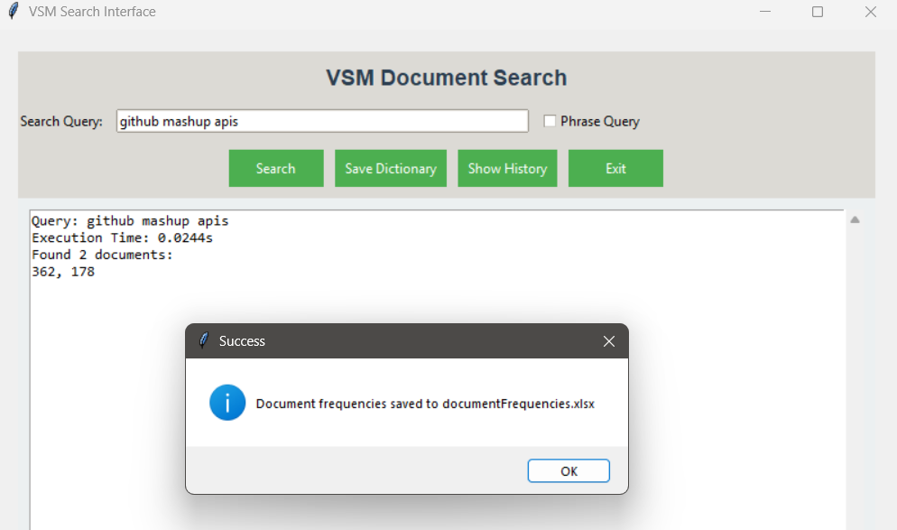

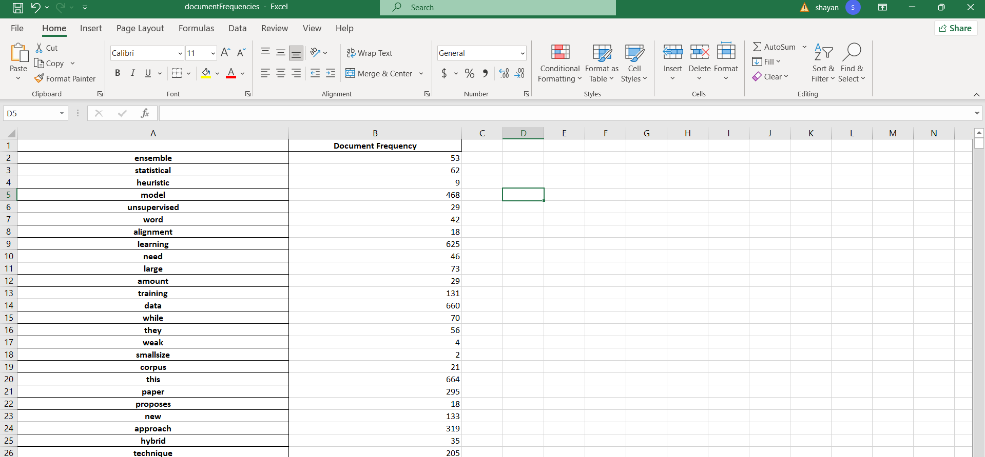

TRACK SEARCH HISTORY:

